# ProjectDocumentation

# *RhythmicTunes:YourMelodic Companion*

1**.Introduction**

Project title: RhythmicTunes:Your melodic companion

Team id:NM2025TMID32352

Team Leader: Rasheedha Maryam B & [rasheedhamaryamb@gmail.com](mailto:rasheedhamaryamb@gmail.com)

Team Members:

Rakshana Begam k [&raks2007raks@gmail.com](mailto:&raks2007raks@gmail.com)

Ramya D & [ramyadurairaj61@gmail.com](mailto:ramyadurairaj61@gmail.com)

Rashiya R & [rashiyaramaiya@gmail.com](mailto:rashiyaramaiya@gmail.com)

2.**Project Overview**

Purpose:

Preserving and Promoting traditional rhythms and music.Creating engaging music for audiences.

Features:

Rhythm Games

Music library

Collaboration platform

Sharing Capabilities

3.**Architecture**

Fronteend: React.js with Bootstrap Material UI

Backend: node.js and Express.js managing server logic and API endpoints

Database: MongoDB stores user data,project information ,applications,and chat messages

4**. Setup Instruction**

Prerequisites:

Node.js and npm

React.js

Installation Steps:

#Clone the repository git clone

#Install client dependencies cd client npm install

#Install server dependencies cd../srever npm install

**5. Folder Structure**

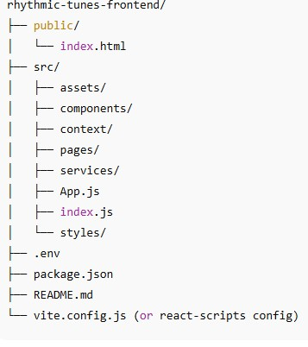

**6.Running Application**

**Fronted:**

Cd client

Npm start

**Backend**:

Cd server npm

Start

**Access**: Visit https:\\localhost:3000

7**.API Documentation**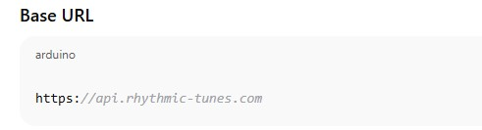

**8.Authentication**

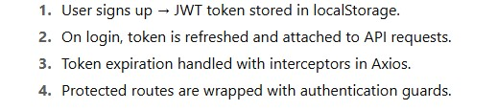

9.**User Interface**

b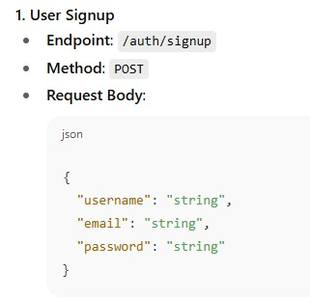

**10.Testing**

Manual testing during milestones

Tools:postman,chrome Dev tools

11**.Screenshots**

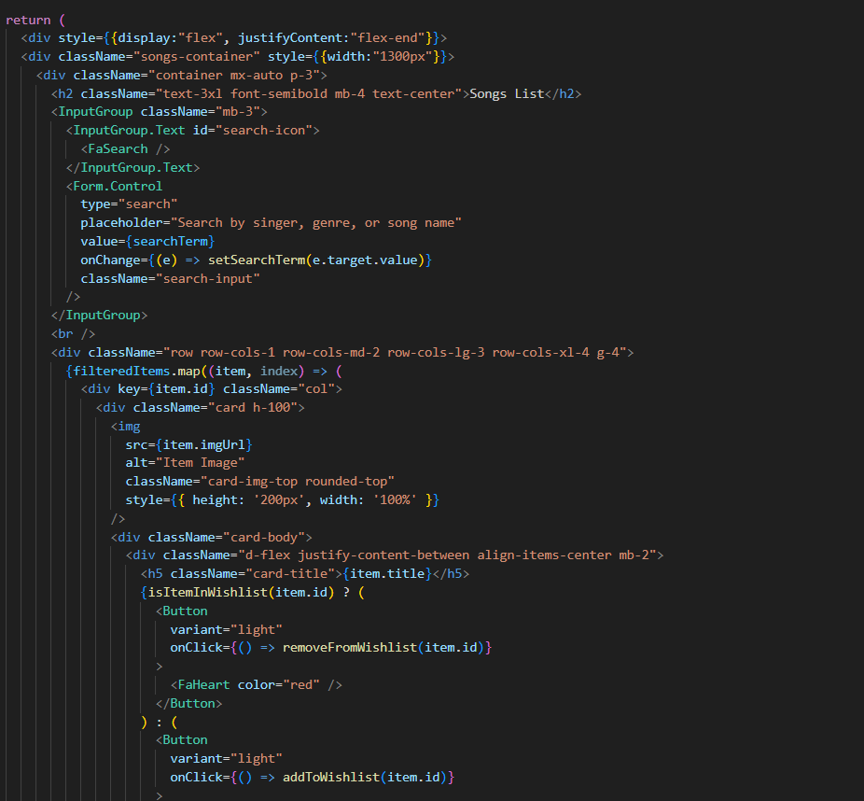

**12.Future Enhancements**

Add real time collaborative playlist.

Offline playback using service workers.